Class # 3 – Creating Effective Electronic Presentations Using PowerPoint

1. How do create slides with a specific background I choose? Contents of my CD “Examples”
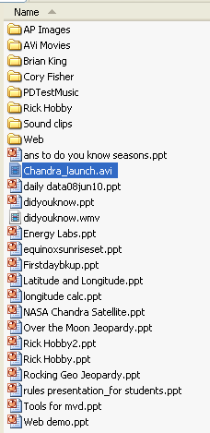
2. How do I add a soundtrack to my PowerPoint presentation?
3. What ways may I use to add sound to my presentation?
4. How do I use Audacity?
5. How do I create a question and answer review for my classes?
6. Complete assignment #2 and #3

Contents of my CD “PTT Templates”

